Club History
The Early Years

Twelve years after the formation (1883) of the rugby side in Gorseinon, their application to become members of the Welsh Rugby Union in 1895 was successful. This coincided with the appointment of Sir John Llewellyn, Bart, M.P., as President of the W.R.U.

In those days they played on the Welfare Ground then called Kings Holme with Cricket and Soccer also being played there. After the World War, the club played under the name of St Catherine's Church down in the lower part of Gorseinon, at the rear of Whittington Terrace. The ground was called Pencefnarda and the changing rooms were at the back of the 'Institute'. Between 1918 and 1931 the ground was redeveloped by the owners of the local works Messrs. Lewis and sons, and the club started playing under the name of 'Grovesend Welfare'.

At the outbreak of the 1914-18 war the team was disbanded and although reforming in 1931 under the works name it was not until 1936 that they were re-admitted into the Welsh Rugby Union. In the early 1950's an application was made to change the name back to Gorseinon and it's original title.

The club's colours have always been cherry and white but Mr. Dick James who was a great stalwart of rugby and cricket in Gorseinon always argued that the first set of jerseys were claret and cream. They were donated by a local solicitor, Mr. Harold Williams. Dick James was a very colourful character captaining Gorseinon before the 'Great War' and his claim to fame was that he was a sparring partner to the great Jimmy Wilde. He was a life member of the club for many years and was active in committee work until his death in the 1960's.

From 1930

In the early 1930's the club chairman was Alderman William Evan, with Mr. T.S. Edwards as secretary and Mr. Sid Williams as treasurer. Messrs. T.B. Bevan, Elvet Lewis, W. Lang, W. Inkin and W. John became the backbone of the committee until the outbreak of the 2nd World War.

Gorseinon have always practiced the gospel of the open game with their lively attitude to rugby, and through the years many fine players have been connected with the club, especially in the 1930's. Malcolm Jones who played at centre with Swansea and Llanelli, Cyril Berry, Jim Lang, Tom Day, Idwal Davies and Ernie Rees who captained the team in the 1935-36 season were prominent.

The first match to be played by Gorseinon after the Second World War took place on 3rd September 1945, barely a month aftr the end of the War which ended on 8th August 1945.

Largelly responsible for arranging the fixture were Will Lang, Benny Bevan and Reg Gale. the opponents were Gowerton. Gorseinon lost 14-0. At his time the Gorseinon team were known as Grovesend Welfare (Gorseinon) as we were largely sponsored by the local tin plate works.

Those taking part for Gorseinon in that first match were Roy Evans (Beer Bach) at 15 years 10 ½; months, the youngest player ever to play for gorseinon. Les Jones (Zebs) at 15 years 11 months was the second youngest. Elgan Davies (Gato) 16 ½; years and Lyn Evans also 16½; years.

It was possible for those young players to play for Gorsinon as there was no Second XV and the Youth Team had not started.

Season 1945-46 was an unofficial season but a full list of 42 fixtures was played.

Tom Phillips of Spring Gardens Gorseinon was later elected as Captain.
The first season after the war, 1946-47, with T.B. Bevan, chairman, W. Lang, secretary and W. John, treasurer, the club was captained by Mr. Pat Murphy, and although not enjoying a good season, record wise, at least the club had been re-established after six years of inactivity. One must be greatful to those people at the helm together with vice chairman Elvet Lewis, and J.R. Gale, D.L. Evans, W. Inkin, H. Harrison, Reg Skyrme, Dai Illtyd Williams and C. Moore of the committee.

A significant development in season 1948-49 was the establishment of a youth team to bridge the gap between school and senior rugby. Will Lang was ably supported by Mr. Hermas Evans. Mr. Will Lang had been very conscious of the void in Welsh rugby circles for teenagers whose schoolboy days were only just behind them. it speaks volumes for the club that Hermas Evans was elected secretary of the new Welsh Youth Rugby Union, a position he held until 1955. Later he was to serve as W.R.U. Representative from 1963 until 1982 and during his term of office he had the distinction of being Chairman of the International Board sitting with Mr. Danie Craven "Mr. South Africa" of Springbok rugby.

In the late 1940's a most illustrious character played for Gorseinon, namely Mr. Doug Jones who went on to play in the front row for Swansea for many seasons. he had two final trials for Wales and has always been regarded as very unfortunate not to be capped.

1950 saw change at the helm of the Gorseinon Rugby Club with the introduction as chairman, of Mr. Elvet Lewis who served the club as committeeman, vice chairman and chairman for 35 years, also Mr. Len Roberts a past player of the club who became treasurer and held the position for 28 years and is still an active life member.

As the years went on the club had some lean times on the playing field but in 1955 under the captaincy of Louis Gazzi they went to the semi-final of the W.W.R.U. cup at Swansea ground , St. Helen's against Seven Sister's only to lose in the replay 5-3

The following year they were again successful and reached the semi-final against Carmarthen after a marathon of replays with Penclawdd.

Gorseinon's most outstanding team during their history to date was that of 1962-63 which won the West wales R.U Championship by beating Carmarthen at Stradey Park, Llanelli. Seven members of the team had played first class football at sometime or another and it was captained by Alan Jones who had played with Swansea and Neath. The era naturally is regarded as the most successful in the history of the club and several new records were established with wing Billy Sweetman scoring six tries against Abercrave. In season 1966-67 we saw the club playing in both semi-finals of the W.W.R.U. competitions, but losing to Pontarddulais in the Cup and Seven Sisters in the Championship.

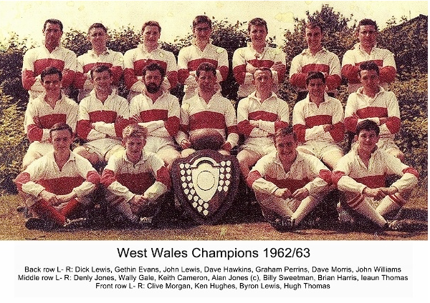

Season 1969-70 heralded the re-introduction of a Youth team which had not been operating for nine years and many fine players were produced including three internationals:- Adrian Walters, John Morgan and John Madden with Malcolm Hedges reserve to the great Terry Homles in the 1974 Welsh Youth team.

As previously mentioned the Youth of 1969 produced internationals, but one player who bettered himself in later years was David Cole. he played for three seasons for Neath and captained the club in1980 and along with Alan Jones (brother of Lewis).

Some quality teams have been produced in the 1970's, with perhaps the clubs greatest day in this era in the XV a side game being 1st January 1976 when Gorseinon played Cardiff at the Cardiff Arms Park only to lose 68-13 scoring two quality tries. This followed a run of three successful games in that years Welsh Cup competition beating Llangennech and Llandovery at home cumulating in a veritable battle of a game away at Laughane.

During this period the club won the district 'F' sevens title on four occasions - 1975,1976,1982 and 1986 with both Bryon Gale (1975) and John Lewis (1982) receiving Man of the Tournament Awards and David Cole, Huw Watkins and Alun James achieving highest scorers in the Tournament. David Cole appeared in all four winning sides. Cole also played for four seasons with Neath between1976-1980. winning player of the year award and captaining the side in his last year, only the late Alan Jones (Llanelli)- brother of Lewis and Lyndon Lewis (Aberavon) have captained first class teams being former Gorseinon players.

The side were runners up in Section 'D' of the West Wales Championship ( which had been revamped in the 1974-75 season). In 1981 and again in 1988 under the coaching of John Evans & Wynford Davies and the captaincies of Malcolm Hedges & Andrew Gazzi respectively. The club also reached the semi finals of the West Wales Cup in 1982 losing to Hendy 19-13 at Stradey Park in a close faught contest, captained by Malcolm Hedges and coached by David Cole.

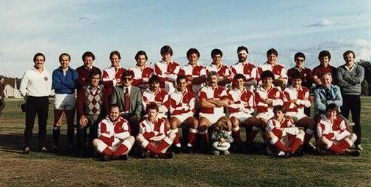
Centenary Season 1st XV

In 1988 the Second XV under the captaincy of the ever youthful Andrew Thomas and coached by Roger Slack, won the Swansea and District Championship final against Mumbles 14-9.

In 2001 the First XV coached by Anthony Griffiths and captained by Mark Crahart gained promotion to Division 4 (West) by winning a play off match against Pill Harriers 45-15. What a day that was !!

21st Century - Ground Redevelopment

During 2007 a new building appeared on the grounds and the playing fields saw the introduction of new banking, fences, storerooms, a cricket scoreboard, dugouts and flower beds!
2012 saw work start on the "Leigh Halfpenny Pavillion" which was officially opened by Leigh on the 10th May 2013
Famous players from Gorseinon RFC
The club has produced or developed numerous notable players, including:
* Leigh Halfpenny
* Dan Biggar
* Ross Moriarty
* Eli Walker
* Lewis Jones
* Norman Gale
The Welfare Ground
The club’s spiritual home remains the Welfare Ground, central to community rugby in Gorseinon for generations.
The ground symbolises the connection between Welsh rugby clubs and the industrial communities that built the sport in South Wales.
Legacy
Gorseinon RFC represents a classic Welsh rugby story:
* born from an industrial community
* interrupted by two world wars
* rebuilt through volunteers and local pride
* sustained by youth development and community identity

The club’s “Cherry and White till I die” spirit still reflects the deep emotional connection between rugby and community life in Gorseinon.
Leigh Halfpenny Rugby Achievements
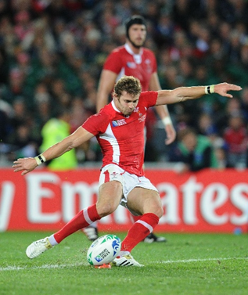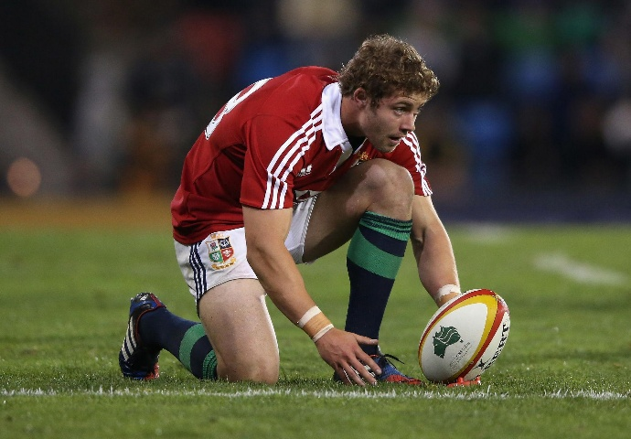

Leigh Halfpenny is widely regarded as one of the finest full-backs and goal-kickers of the professional era in Welsh rugby. Born in Gorseinon, Swansea, he rose from local rugby through Gorseinon RFC to become a Wales and British & Irish Lions legend.
International Career – Wales
• Made his Wales debut in 2008 aged just 19.
• Won over 100 caps for Wales, placing him among the country’s most capped players.
• Played in:
o multiple Six Nations Championships
o several Rugby World Cups
o Autumn Internationals against the world’s top nations.
• Helped Wales win:
o the 2012 Six Nations Grand Slam
o the 2013 Six Nations Championship
o the 2019 Six Nations Grand Slam.
British & Irish Lions
Halfpenny became one of the most successful Lions players of the modern era.
2013 Lions Tour to Australia
• Played a starring role in the series victory over Australia.
• Was named:
o Player of the Series
o top points scorer on the tour.
• Broke the Lions points record in a test series.

2017 Lions Tour to New Zealand
• Selected again for the Lions squad.
• Played key matches before injury curtailed involvement.
Club Career
He played professionally for:
• Ospreys
• Cardiff Rugby
• RC Toulon
• Scarlets
At Toulon in France, he helped win major domestic honours and became known internationally for his elite kicking accuracy and defensive reliability.
Playing Style and Reputation
Halfpenny was renowned for:
• exceptional goal-kicking accuracy
• bravery under the high ball
• world-class positional play
• reliable defence
• consistency under pressure.
His calm temperament and professionalism earned enormous respect throughout world rugby.
Major Honours
• 100+ Wales caps
• Multiple Six Nations titles
• Two Grand Slams
• British & Irish Lions series winner
• 2013 Lions Player of the Series
• Lions test points record holder (2013 series)
• Widely considered one of Wales’ greatest modern full-backs
Legacy
For many Welsh supporters, Leigh Halfpenny represents determination, humility, and professionalism. His rise from community rugby at Gorseinon RFC to the pinnacle of international rugby remains one of modern Welsh rugby’s great success stories.

Dan Biggar Rugby Achievements

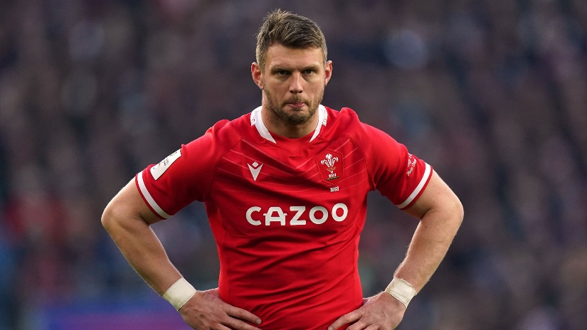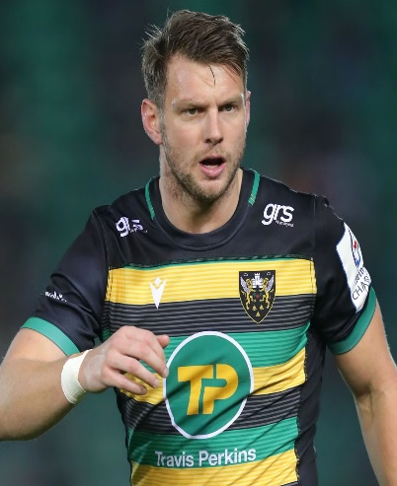

Dan Biggar is one of the most accomplished fly-halves in Welsh rugby history, known for his competitiveness, tactical kicking, leadership, and big-game mentality. Raised in Gorseinon and developed through Gorseinon RFC,
he became a central figure for Wales over more than a decade.
International Career – Wales
• Made his Wales debut in 2008.
• Earned more than 100 caps for Wales.
• Became one of Wales’ leading points scorers in international rugby.
• Represented Wales in:
o multiple Six Nations Championships
o three Rugby World Cups (2011, 2015, 2019)
o numerous Autumn Internationals.
Major Wales Honours
Biggar played key roles in several championship-winning campaigns:
• 2012 Six Nations Grand Slam
• 2013 Six Nations Championship
• 2019 Six Nations Grand Slam
• 2021 Six Nations Championship
He was widely praised for controlling matches through tactical kicking, game management, and defensive intensity.

Rugby World Cup Success
2011 Rugby World Cup
• Part of the Wales squad that reached the semi-finals in New Zealand.
•
2015 Rugby World Cup
• Produced standout performances despite Wales suffering major injuries during the tournament.
2019 Rugby World Cup
• Helped Wales reach the semi-finals again.
• Played through injury and was one of Wales’ most influential players during the campaign.
British & Irish Lions
Dan Biggar was selected for the:
• 2017 British & Irish Lions Tour to New Zealand
• 2021 British & Irish Lions Tour to South Africa
On the 2021 tour he started test matches and became a major tactical leader for the side.
Club Career
He enjoyed major success with:
• Ospreys
• Northampton Saints
• RC Toulon
Ospreys
• Won multiple Celtic League/Pro12 titles.
• Became one of the region’s most important modern players.
Northampton Saints
• Became a fan favourite in England’s Premiership.
• Helped guide the club to strong league and European performances.

Playing Style and Reputation
Biggar became famous for:
• elite tactical kicking
• emotional intensity
• strong defensive work for a fly-half
• leadership under pressure
• competitive mentality.
He was respected across world rugby for his toughness and ability to perform in high-pressure matches.
Major Achievements
• 100+ Wales caps
• Multiple Six Nations titles
• Two Grand Slams
• Two Rugby World Cup semi-finals
• Two British & Irish Lions tours
• Multiple league titles with Ospreys
• One of Wales’ highest international points scorers
Legacy
Dan Biggar is regarded as one of the defining Welsh fly-halves of the professional era. His journey from Gorseinon RFC to captaincy and international success reflects the strength of Welsh community rugby and player development.

Ross Moriarty Rugby Achievements
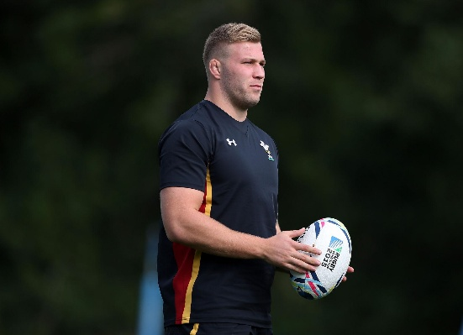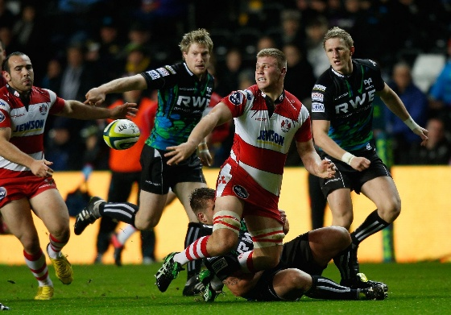

Ross Moriarty is a Welsh international rugby union forward known for his aggressive ball-carrying, physical defence, and versatility across the back row.
Early life and rugby background
Born on 18 April 1994 in St Helens, Australia, Moriarty comes from a famous rugby family:
• Son of former Wales international Paul Moriarty
• Grandson of former Wales player Richard Moriarty
He moved to Wales as a child and developed through the junior system at Gorseinon RFC before joining the Gloucester academy.
Club career achievements
Gloucester Rugby
Moriarty broke through at Gloucester as a teenager and quickly became known as one of the most powerful young forwards in English rugby.
Key achievements:
• Senior debut in 2012
• European Challenge Cup winner in 2015
• Became a regular Premiership starter before age 21
Dragons RFC
He signed for Dragons RFC in 2018.
Achievements included:
• Became one of the region’s marquee Welsh internationals
• Regular captaincy and leadership roles
• Central figure in Dragons’ forward pack for several seasons
Brive
In 2023, Moriarty moved to French rugby with CA Brive, continuing his professional career in the French league system.
Wales international career
Moriarty earned his first cap for Wales national rugby union team in 2015.
Major international achievements
• Over 50 international caps for Wales
• Represented Wales at:
o 2015 Rugby World Cup
o 2019 Rugby World Cup
• Part of Wales squads that won:
o 2019 Six Nations Championship
o 2021 Six Nations Championship
2019 Rugby World Cup
One of Moriarty’s standout periods came during the 2019 World Cup in Japan:
• Key starter in Wales’ run to the semi-finals
• Produced dominant performances against Australia and France
• Praised for high work rate and physical intensity
British & Irish Lions
Moriarty achieved one of rugby union’s highest honours when selected for the:
• British & Irish Lions 2017 tour to New Zealand
Achievements on tour:
• Played in test rugby against the New Zealand national rugby union team
• Became one of a select group of Welsh forwards chosen for a Lions tour in the professional era
Playing style and reputation
Moriarty became known for:
• Explosive carrying ability
• Fierce tackling
• High-energy performances
• Emotional competitiveness and intensity
At his peak, he was regarded as one of Wales’ most destructive blindside flankers and No. 8s.
Overall legacy
Ross Moriarty’s career achievements include:
• International success with Wales
• Multiple Six Nations titles
• Rugby World Cup semi-finalist
• British & Irish Lions tourist
• Professional rugby success in England, Wales, and France
He also continues the rare three-generation Moriarty family tradition of Welsh international rugby representation.

Eli Walker rugby achievements
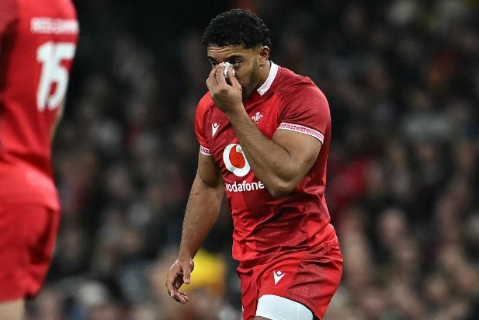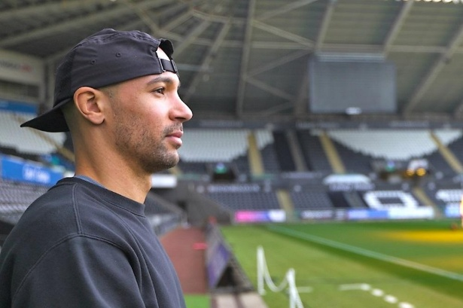
Eli Walker is a former Welsh rugby union winger and full-back remembered for his exceptional pace, attacking flair, and unfortunate injury-interrupted career.
Early rugby career
Born in 1992 in Swansea, Walker developed through the youth ranks at:
• Gorseinon RFC
He quickly gained attention as one of the most exciting young backs in Welsh rugby because of his acceleration, footwork, and finishing ability.
Ospreys breakthrough
Walker came through the academy system at:
• Ospreys
Key achievements with Ospreys
• Senior debut as a teenager
• Became a regular regional player in the Pro12
• Earned a reputation as one of Wales’ fastest outside backs
• Scored numerous highlight-reel tries for Ospreys
He was especially known for counter-attacking rugby and broken-field running.
Wales international honours
Walker earned selection for:
• Wales national rugby union team

International achievements
• Wales debut in 2013 against Japan
• Scored tries during his international appearances
• Part of Wales squads during the 2013–14 international period
Many Welsh rugby observers regarded him as a future long-term international wing before injuries disrupted his progress.
Sevens rugby success
Walker also represented:
• Wales national rugby sevens team
His speed and open-field running made him particularly effective in the sevens format.
Injury challenges
A major aspect of Walker’s career story was repeated injury setbacks, particularly serious back and neck problems.
These injuries:
• Limited his international appearances
• Interrupted his development during key years
• Ultimately forced an early retirement from professional rugby
Despite showing elite attacking potential, his career ended much earlier than many expected.
Playing style
Walker was widely admired for:
• Exceptional speed
• Evasive running
• Counter-attacking instinct
• Natural try-scoring ability
At his peak, he was considered one of the most naturally gifted attacking backs produced in Welsh regional rugby during the early professional era.
Legacy
Although injuries shortened his playing career, Eli Walker remains highly regarded among Ospreys and Welsh rugby supporters as:
• one of the most exciting Welsh backs of his generation
• a standout product of Gorseinon RFC youth development
• a player whose full international potential was never fully realised due to injury

Lewis Jones Rugby Achievements
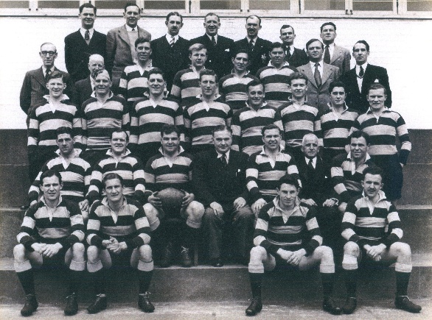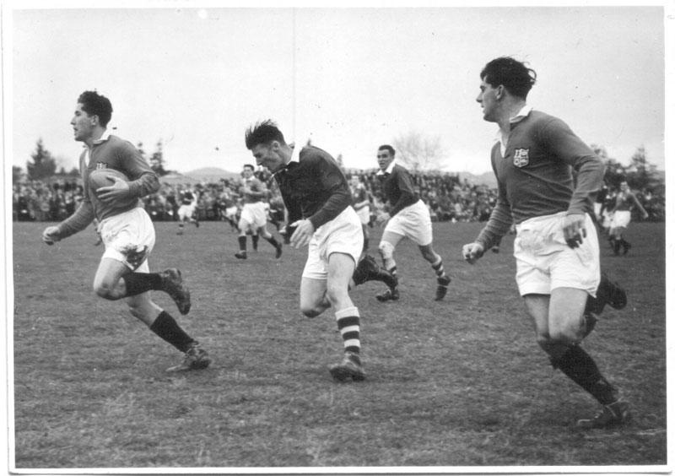

Lewis Jones
Lewis Jones (1931–2024) was a Welsh dual-code rugby international celebrated as one of the sport’s most gifted attacking players. Known as the “Golden Boy,” he starred for Wales and the British & Irish Lions in rugby union before a record-breaking switch to rugby league with Leeds Rhinos. His dazzling skill, goal-kicking precision, and longevity made him one of Wales’s greatest all-round athletes.
Key facts
• Full name: Benjamin Lewis Jones
• Born: April 11, 1931, Gorseinon, Wales
• Died: March 4, 2024, Leeds, England
• Rugby union caps (Wales): 10 (1950–1952)
• Rugby league record: 2,920 points for Leeds; 15 Great Britain caps
• Honors: Inducted into Rugby League Hall of Fame (2013)
Early career and union success
Jones made his international rugby union debut for Wales in 1950 at just 18, helping secure the nation’s first Grand Slam in 39 years. He repeated the feat in 1952. That same year, he joined the British & Irish Lions tour as an injury replacement, playing three Tests and topping the scoring charts. His flair and composure under pressure quickly established him as one of Wales’s brightest talents.(Welsh Rugby Union)
Switch to rugby league and dominance
In late 1952, Jones signed professionally with Leeds RLFC for a then world-record fee of £6,000. Over twelve years, he scored 144 tries and 1,244 goals in 385 matches, leading Leeds to Challenge Cup triumphs and the club’s first Championship in 1961. In the 1956–57 season, he set a world record of 496 points, cementing his place as one of rugby league’s most
prolific scorers.(Yorkshire Post)
Legacy and later life
Jones’s vision, unorthodox creativity, and match-winning brilliance made him a fan favorite in both codes. After his playing days, he taught mathematics and coached in Australia and the UK. Honored by multiple halls of fame, including the Welsh Sports Hall of Fame, his name graces a suite at Headingley Stadium. His enduring influence marks him as one of the defining figures of Welsh and British rugby.(Welsh Sports Hall of Fame)

